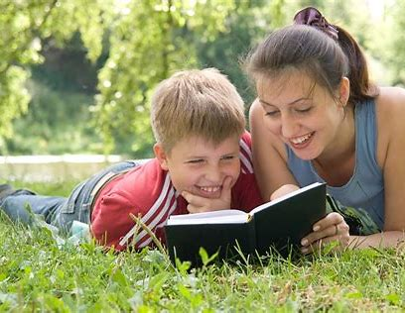**Why is reading so important?**



Reading at home **Year 1**

There is a vast amount of research that shows us how important reading with our children is. It helps to improve your child’s concentration and memory, develop their imagination, empathy, vocabulary and listening skills and takes them (and us!) to places we might never otherwise visit. It’s also excellent for wellbeing.

**The Importance of Reading Aloud to your Child**

**Reading aloud to your child** is very beneficial for them, even when they can read by themselves. In fact, research shows that reading aloud to your child after the age of 5 will improve their reading and listening skills and academic performance.

**How else does reading aloud to your child help?**

**Positive modelling:** Your child will hear how the book should be read -with lots of expression and at just the right speed.

**It improves comprehension:** Your child will be able to focus on what’s happening in the story or on the information in the text, rather than having to work hard to read it aloud themselves.

**It sparks curiosity and a thirst for learning:** You can use books to guide your child to find out more about the things you are reading and talking about.

**It is wonderful for bonding:** It’s a lovely opportunity for you to spend some dedicated time with your child, showing them how important they are and how important reading is.

**Getting the Most Out of Reading with your Child**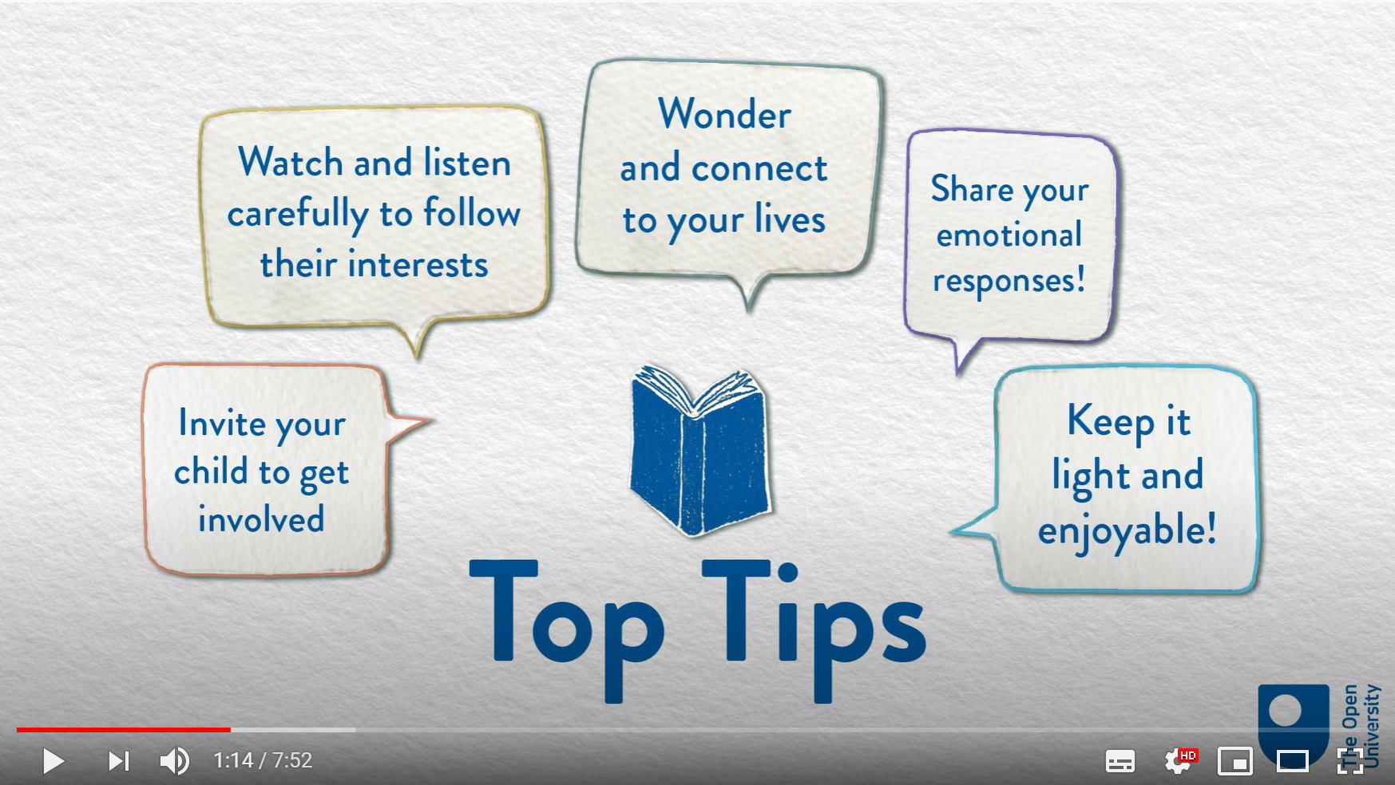

Watch this short video from The Open University to help you get the most out of reading with your child

Book Chat: Reading to your Child *One Fox*: <https://youtu.be/sKFdKs_2wJY>

**Listening to Your Child Read Aloud**

* Try to **listen to your child read** aloud daily. Little and often is best. 5 - 10 minutes is usually long enough.

**Join the FREE online library**



<https://www.readliverpool.co.uk/>

You can borrow 8 virtual books at a time for free!

* Choose a quiet, undistracted time and snuggle up.
* Use the book that school has sent home specifically for this reason.
* Re-read the same text over the course of a week. This will help to build up your child’s fluency.
* When your child tries to 'sound out' words, encourage the use of phonics letter sounds rather than 'alphabet names'. So for ‘cat’ you’d say c-a-t, not C-A-T.
* Be positive. Give lots and lots of praise.

©School Improvement Liverpool 2020

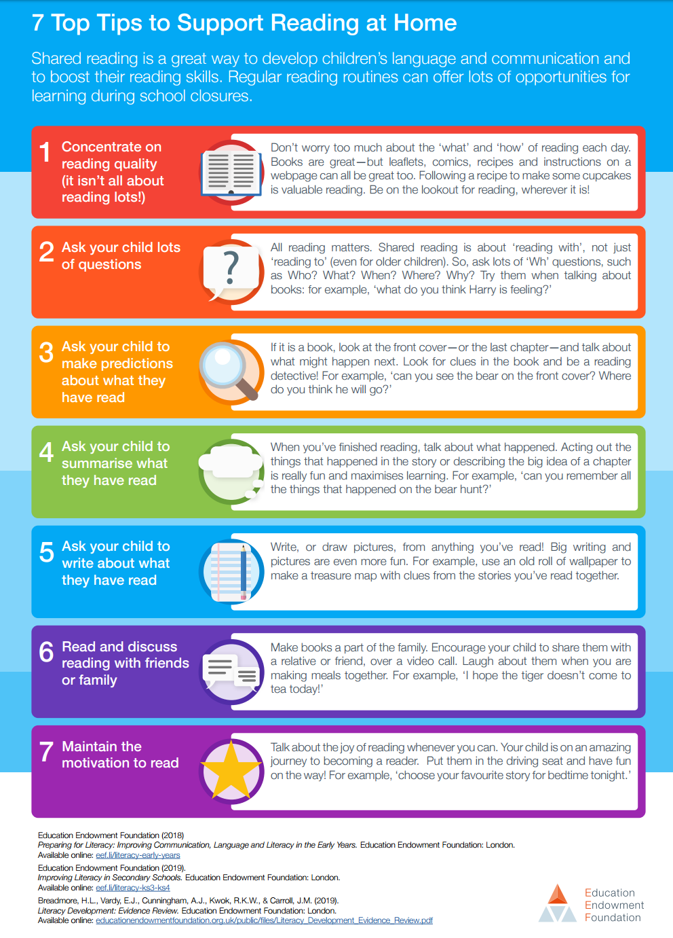

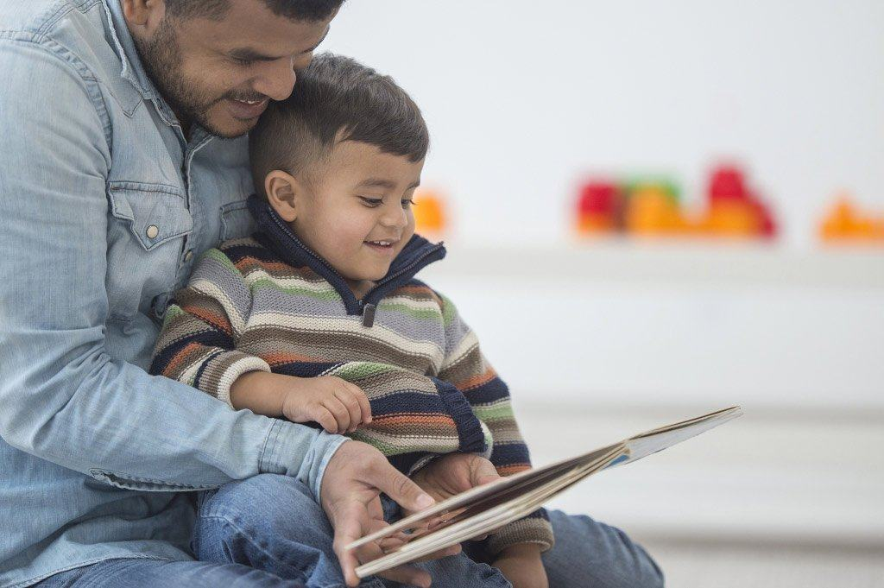

Questions to ask while reading with your child

It’s important to ask questions when you are reading to your child and when

your child is reading to you. You can ask questions before, during and after

reading. Questions can help you to see whether you child has understood what

you’ve read together. You can ask your child about:

**Words**

Find a word that means the same as…

Which word makes you feel _______?

What does this word mean?

**Finding information**

What are the characters called?

Where did ________ live?

What word is used to describe the …?

**Putting things in order**

What happened after ___?

What happened before __?

What happened in the beginning, middle and end of this story?

**Using clues**

Why do you think the character is feeling (*e.g. sad*) here?

Why do you think the character did that?

Can you explain why…?

What word is used to describe the …?

**Predictions**

What do you think might happen next?

What would you do if you were this character? Why? Do you think this character will do the same as you?

**Deepening understanding**

How do you know that?

Why do you think that?

What do you mean by…?

©School Improvement Liverpool 2020