



Writing at Home **Year 1**

**Be chatterboxes!**

**Talking for Writing**

Children love to talk and it’s so good for them too! In fact, talking **with** your child is one of the most powerful activities you can do. Take turns to speak and listen to each other. Use a wide range of vocabulary and try to use the new words you have discovered when reading together. Talk about everything: how your food tastes, experiences you can remember, what you can see in the world around you. All of this talk helps children to explore and understand language and can have a really positive impact on their writing.

What are you going to write about?

Encourage your child to talk about, or say out loud, what they are going to write. This helps them to prepare for writing.

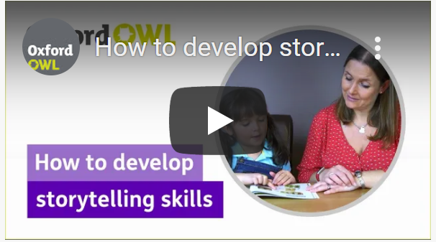**Be storytellers!**

Can you say the sentence aloud before you write it down?

Watch this short video from Oxford Owl to learn about how to develop storytelling skills with your child.

<https://youtu.be/F8k93ylkBPA>

Can you read aloud what you have written?

**Handwriting**

In Year 1, your child will continue to master using a pencil and to form basic letter shapes. This includes:

* sitting correctly and using the right grip
* forming lowercase and capital letters correctly, starting each letter in the right place
* 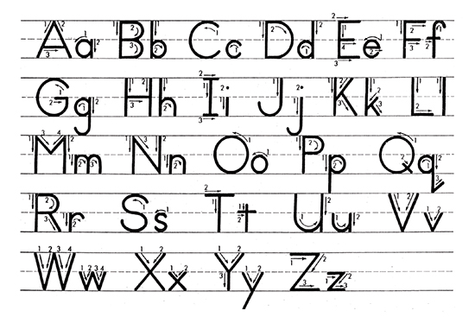forming the digits 0–9
* ****leaving a clear finger space between words.

 Sit at a desk

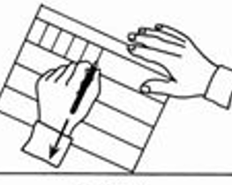 Put both feet on the floor

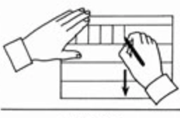 Left hand paper position

Right hand paper position

**How can I motivate my child to write?**

* Make sure your child knows their work doesn’t have to be perfect first time. They can go back and make improvements later.
* At this age, your child’s hands can tire easily during writing. Give them regular breaks and ensure that the pen or pencil they are using is the right size for them.
* Try creating a story box filled with items around their interests and hobbies. When your child spots something they are interested in, their creativity will flow.

©School Improvement Liverpool 2020

Writing checklist:

Can your child write a simple sentence?

Can your child write their own full name clearly?

**Can your child spell these tricky words?**

he, she, we, me, be, you, all, are, her, was, they, my

**Can your child tell you what these words are/mean?**

Letter one of the symbols of the alphabet

Capital letter/ one of the letters of the alphabet used at the beginning of a

Uppercase letter name or sentence

Lowercase letter any letter that is not a capital letter

©School Improvement Liverpool 2020

Other ways you can make a big difference

**Developing gross motor skills:**

**Visit your local playground.** Playgrounds are all different and require different skills, so visit several in your area. While you are there, you can practice different skills such as climbing, balancing or teach your child how to swing by themselves. Learning to ride a bike without stabilisers is fabulous for gross motor skills.

**Play ball**. Using both small and large balls, you and your child can focus on developing and improving throwing, catching and kicking skills.

**Developing fine motor skills:**

**Playdough.** Encourage your child to squeeze, stretch, pinch and roll “snakes” or “worms” with the play clay. Challenge your child to add small details.

**Cutting.** Encourage your child to cut out shapes from paper carefully. <https://www.nhsggc.org.uk/kids/resources/ot-activityinformation-sheets/scissor-skills/>

**Good gross and fine motor skills help your child to write**!

©School Improvement Liverpool 2020

Important Information