

Year 1
Supporting your child with English at home



Home-learning can be challenging for both you and your child as everyone is adapting to this unusual situation. The following advice aims to offer helpful, practical tips with supporting your child’s reading and writing while at home.

Preparing to learn: Some top tips

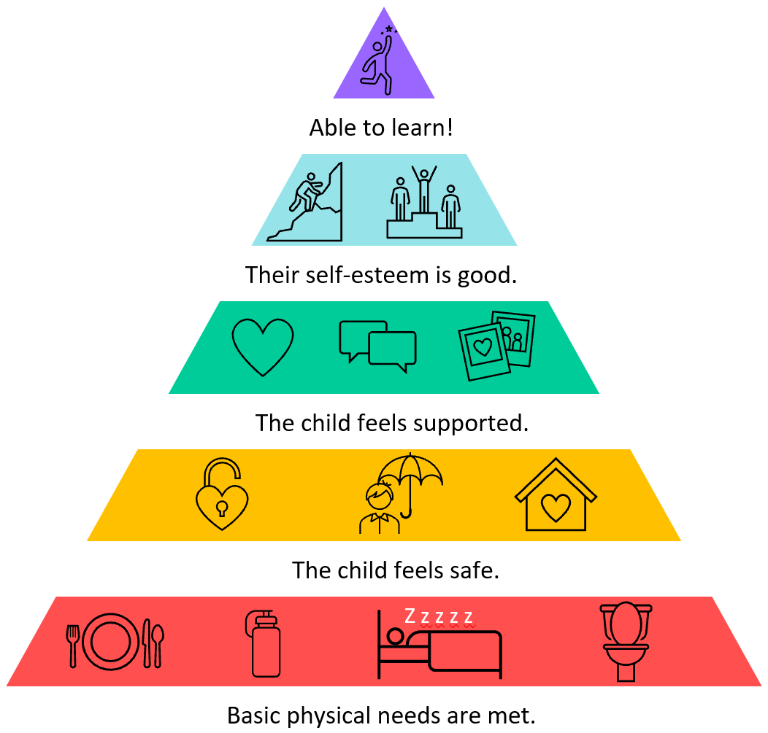
- Ensure your child’s basic needs have been met: Are they thirsty, for example?
- Make sure your child has a clear space to work. Think about the task they have to do – where might they be the most productive/ comfortable?
- Create a new routine that works around your family. If possible, involve your child in establishing routines that will enable them to manage the tasks set for them. Your routines should include regular breaks, ideally with fresh air.
- Tackle tasks in short bursts if your child is finding it difficult to concentrate.
- Where possible, allow your child choices. For example, if your child has been given two tasks for the day, give them the choice of which one to do first.
- Model positive behaviours to your child. Talk about the strategies you use to help you get through your daily tasks. If something isn’t working, talk it though.
- Look for the positives. Things won’t always go according to plan. Try to focus on what is going well rather than what has gone wrong. Try to support your child with lots of praise and encouragement.
- Consider family wellbeing: https://www.nhs.uk/oneyou/every-mind-matters/
- Tips for anxiety: https://www.childrens.com/health-wellness/8-tips-for-managing-childrens-anxiety-about-covid-19
©School Improvement Liverpool 2020

Giving just the right amount of support
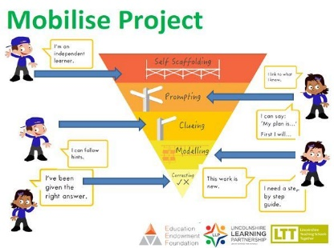
It’s important that you try to encourage independence when working with your child.
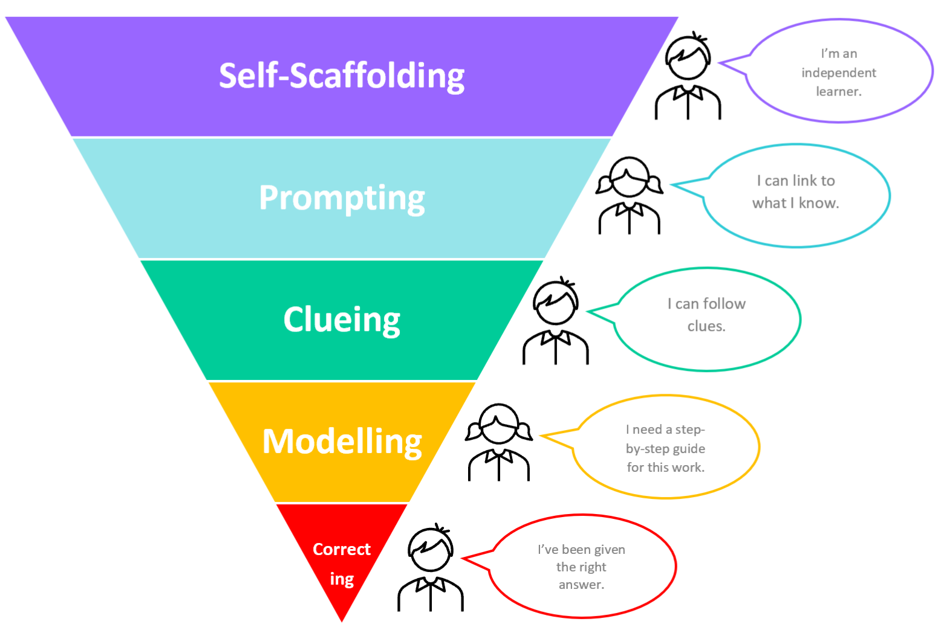
You can do this by:
Self-scaffolding - This is where your child is working largely by themselves.
Prompting - You can give a prompt when your child needs just a little help to carry on working by themselves. For example: ‘What do you need to do first?’, ‘What’s your plan?’, ‘You can do this!’
Clueing - Your child might need a hint about their work to keep them on track. Always start with a small clue, then give a bigger clue if your child needs one. For example, ‘What does a sentence always begin with?’or ‘Let’s go back and re-read this sentence again… I think you might have missed something out.’
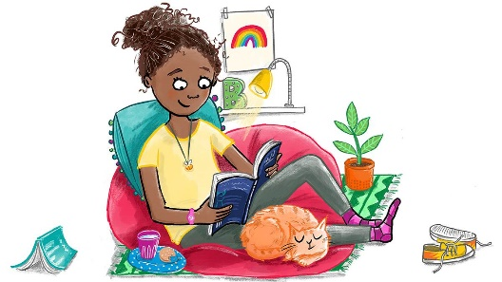
Modelling - Sometimes it is really useful for you to model what to do while your child watches and listens. Your child should try the same step for themselves immediately afterwards.
Illustration: Hannah Shaw
Correcting – Only very occasionally, you may need to give your child answers.
Try to encourage your child to work independently as much as they can.
Adapted from: Bosanquet, P., Radford, J. and Webster, R. (2016)
Take care of yourself too!

Looking after yourself will have an impact on how you support your child at home. Fresh air each day if possible, a few moments of quiet, enough water to drink and some exercise are all good places to start. Be kind to yourself!
(Adapted from the Book Trust Website)

https://www.booktrust.org.uk/news-and-features/features/2020/june/how-to-help-your-children-return-to-school-5-top-tips/

Completing tasks

It’s also important not to be too concerned about your child completing every single task. If your child has tried hard but has not been able to complete a task, let your child’s teacher know. Your child’s teacher recognises how challenging working at home can be for you and your child.
Do what you can: Everybody’s circumstances are different and we do understand that.


©School Improvement Liverpool 2020



Why is reading so important?
School Logo
Reading at home Year 1
There is a vast amount of research that shows us how important reading with our children is. It helps to improve your child’s concentration and memory, develop their imagination, empathy, vocabulary and listening skills and takes them (and us!) to places we might never otherwise visit. It’s also excellent for wellbeing.
The Importance of Reading Aloud to your Child
Reading aloud to your child is very beneficial for them, even when they can read by themselves. In fact, research shows that reading aloud to your child after the age of 5 will improve their reading and listening skills and academic performance.

How else does reading aloud to your child help?
Positive modelling: Your child will hear how the book should be read -with lots of expression and at just the right speed.

It improves comprehension: Your child will be able to focus on what’s happening in the story or on the information in the text, rather than having to work hard to read it aloud themselves.

It sparks curiosity and a thirst for learning: You can use books to guide your child to find out more about the things you are reading and talking about.

It is wonderful for bonding: It’s a lovely opportunity for you to spend some dedicated time with your child, showing them how important they are and how important reading is.

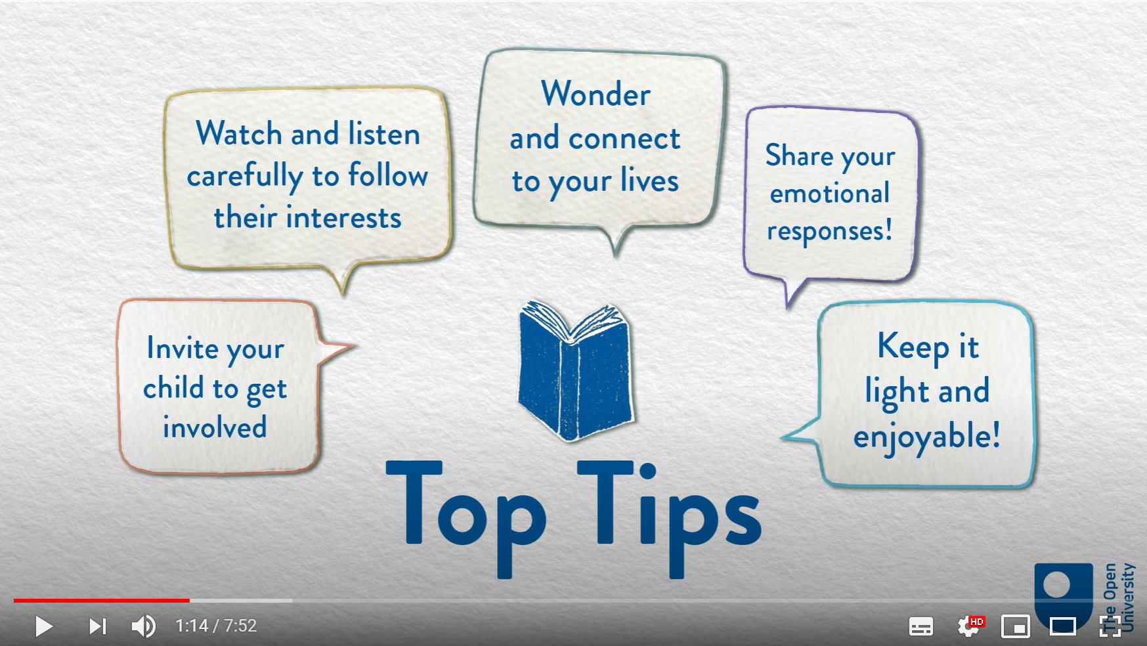
Getting the Most Out of Reading with your Child
Watch this short video from The Open University to help you get the most out of reading with your child
Book Chat: Reading to your Child One Fox: https://youtu.be/sKFdKs_2wJY
Listening to Your Child Read Aloud
- Try to listen to your child read aloud daily. Little and often is best. 5 - 10 minutes is usually long enough.
Join the FREE online library

https://www.readliverpool.co.uk/
You can borrow 8 virtual books at a time for free!

- Choose a quiet, undistracted time and snuggle up.
- Use the book that school has sent home specifically for this reason.
- Re-read the same text over the course of a week. This will help to build up your child’s fluency.
- When your child tries to 'sound out' words, encourage the use of phonics letter sounds rather than 'alphabet names'. So for ‘cat’ you’d say c-a-t, not C-A-T.
- Be positive. Give lots and lots of praise.
©School Improvement Liverpool 2020

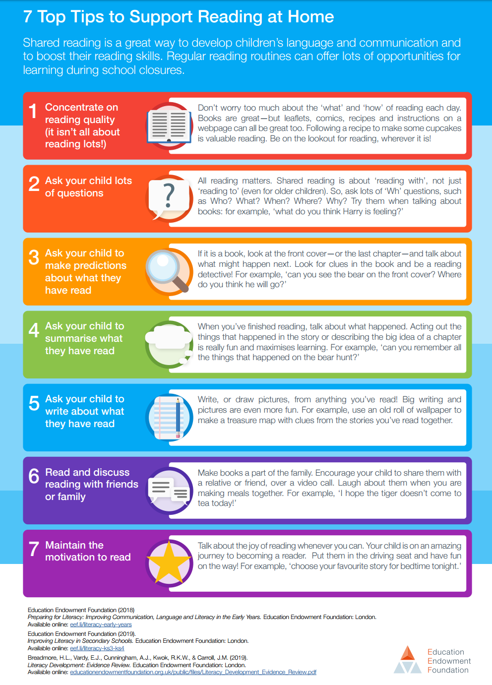

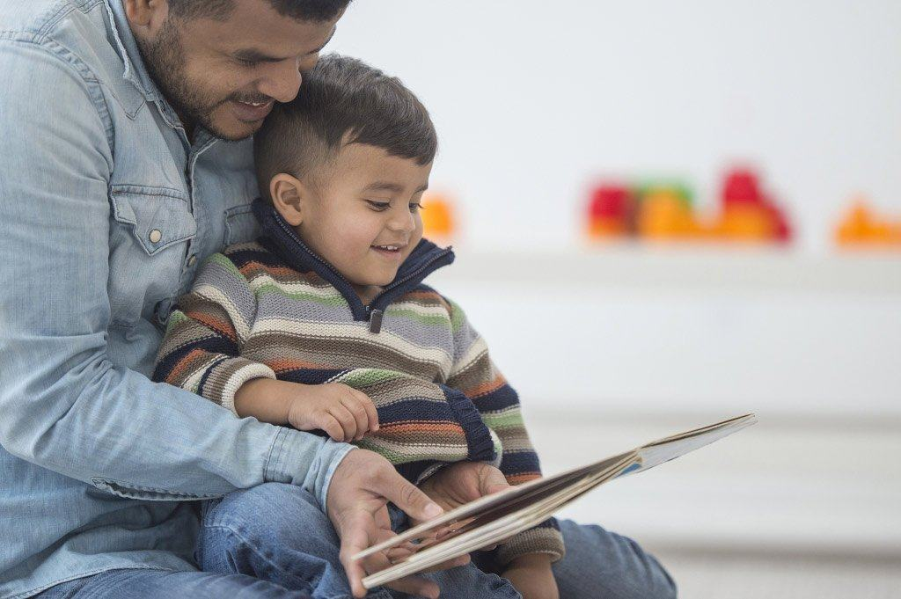
Questions to ask while reading with your child

It’s important to ask questions when you are reading to your child and when
your child is reading to you. You can ask questions before, during and after
reading. Questions can help you to see whether you child has understood what
you’ve read together. You can ask your child about:
Words
Find a word that means the same as…

Which word makes you feel _______?

What does this word mean?

Finding information
What are the characters called?

Where did ________ live?

What word is used to describe the …?

Putting things in order
What happened after ___?
What happened before __?
What happened in the beginning, middle and end of this story?

Using clues
Why do you think the character is feeling (e.g. sad) here?
Why do you think the character did that?
Can you explain why…?

What word is used to describe the …?

Predictions
What do you think might happen next?
What would you do if you were this character? Why? Do you think this character will do the same as you?

Deepening understanding
How do you know that?
Why do you think that?
What do you mean by…?

©School Improvement Liverpool 2020


School Logo
Writing at Home Year 1
Be chatterboxes!
Talking for Writing
Children love to talk and it’s so good for them too! In fact, talking with your child is one of the most powerful activities you can do. Take turns to speak and listen to each other. Use a wide range of vocabulary and try to use the new words you have discovered when reading together. Talk about everything: how your food tastes, experiences you can remember, what you can see in the world around you. All of this talk helps children to explore and understand language and can have a really positive impact on their writing.
What are you going to write about?
Encourage your child to talk about, or say out loud, what they are going to write. This helps them to prepare for writing.

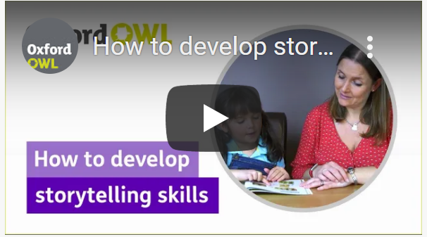
Be storytellers!
Can you say the sentence aloud before you write it down?
Watch this short video from Oxford Owl to learn about how to develop storytelling skills with your child.
https://youtu.be/F8k93ylkBPA
Can you read aloud what you have written?
Handwriting
In Year 1, your child will continue to master using a pencil and to form basic letter shapes. This includes:
- sitting correctly and using the right grip
- forming lowercase and capital letters correctly, starting each letter in the right place
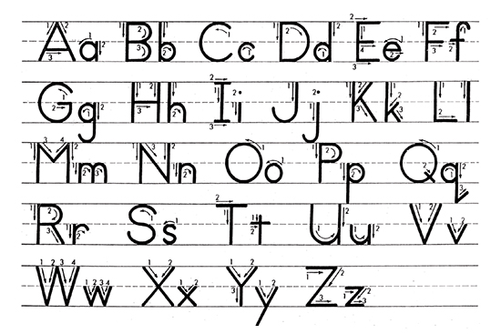
- forming the digits 0–9

- leaving a clear finger space between words.

Sit at a desk
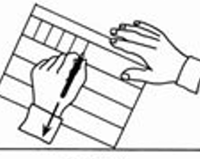
Put both feet on the floor
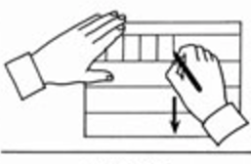
Left hand paper position
Right hand paper position
How can I motivate my child to write?
- Make sure your child knows their work doesn’t have to be perfect first time. They can go back and make improvements later.
- At this age, your child’s hands can tire easily during writing. Give them regular breaks and ensure that the pen or pencil they are using is the right size for them.
- Try creating a story box filled with items around their interests and hobbies. When your child spots something they are interested in, their creativity will flow.
©School Improvement Liverpool 2020

Writing checklist:

Can your child write a simple sentence?

Can your child write their own full name clearly?

Can your child spell these tricky words?
he, she, we, me, be, you, all, are, her, was, they, my

Can your child tell you what these words are/mean?

Letter one of the symbols of the alphabet

Capital letter/ one of the letters of the alphabet used at the beginning of a
Uppercase letter name or sentence

Lowercase letter any letter that is not a capital letter

©School Improvement Liverpool 2020

Other ways you can make a big difference

Developing gross motor skills:
Visit your local playground. Playgrounds are all different and require different skills, so visit several in your area. While you are there, you can practice different skills such as climbing, balancing or teach your child how to swing by themselves. Learning to ride a bike without stabilisers is fabulous for gross motor skills.
Play ball. Using both small and large balls, you and your child can focus on developing and improving throwing, catching and kicking skills.
Developing fine motor skills:
Playdough. Encourage your child to squeeze, stretch, pinch and roll “snakes” or “worms” with the play clay. Challenge your child to add small details.
Cutting. Encourage your child to cut out shapes from paper carefully. https://www.nhsggc.org.uk/kids/resources/ot-activityinformation-sheets/scissor-skills/
Good gross and fine motor skills help your child to write!
©School Improvement Liverpool 2020

Important Information

