Dear Parents and Guardians November 2019

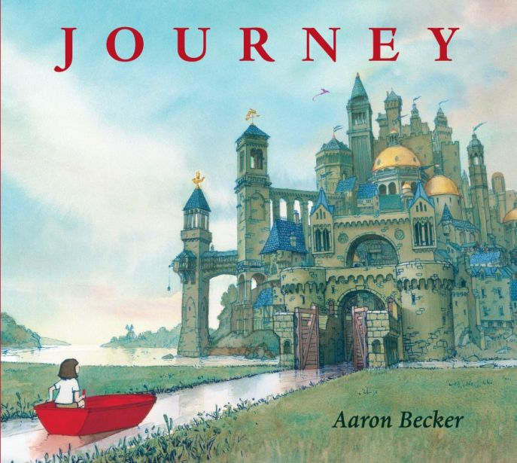
Our ‘Book Week’ this year begins on Monday 11th November. This year the whole school will be looking at the picture book ‘JOURNEY by Aaron Becker. Literacy lessons will come alive with fun activities that are linked to this fantastic book to promote reading for pleasure. We are looking forward to a range of exciting events and activities that will engage the children and their families as much as possible.

Librarians will be coming into school on Thursday and Friday for Storytelling sessions in infants. Parents of children in Nursery are invited to join us for these sessions. (See timetable on reverse for specific details).


We are excited to announce that The Book People will be bringing their book bus to Emmaus this year on Wednesday 13th November. The bus stocks over 250 books and every child in school will be given the opportunity to browse their wide selection throughout the day. If you wish your child to purchase a book, please bear in mind that the average price of a paperback book is £5 and money should be placed in an envelope clearly labelled with your child’s name. Parents of infant children only are invited to accompany their children onto the bus before and after school (see timetable) but please be aware that only 15 people are allowed on the bus at any one time so there may be queues. The Book Bus takes cash or any major debit or credit cards and you will be able to take your books away with you on the day. No book orders can be made. Please note that the school receives 15% commission from the sale of books which funds the restocking of school and class libraries.

Parents of children in Reception, Year 1 and Year 2 are invited to these classes on Wednesday 13th November at 8.55 a.m. to read from a selection of books to individuals and small groups of children. This story reading session will last for only 20 minutes. If you have more than one child in our infant classes you will need to decide which class to visit. We hope this will be a fun activity and that it will give the children a chance to see their parents read for pleasure in school.

We are delighted to host Altru Theatre Company this year. On Wednesday 20th they will perform ‘Road to Respect’ over 2 sessions. The first show will take place in the afternoon for Early Years and KS1 followed by a performance for KS2. Each performance will last for 45 minutes and will focus on moments of choice children make each day in their friendships and interactions and on the importance of showing respect.

We’ve got plenty more planned too, including trips to the Story Barn for Reception, buddy reading between year groups and of course our special Book Week assembly on Friday to celebrate our Book Week activities and showcase the work that we have been doing in class. We look forward to sharing our work with you on our website!

We are very aware that many families are stretched financially in these difficult economic times but we would be unable to provide such a wealth of activities without funding.

We appeal for a contribution of £2.00 from each child to help us meet the cost of the theatre company.

Please send your contribution into school with your child on Monday 11th November

I appreciate that this is a lot of information to remember, and therefore I have summarised the key points into a timetable of events.

Monday 11th | Tuesday 12th | Wednesday 13th | Thursday 14th | Friday 15th
 | RKM to visit Story Barn Calderstones. | Reception, Year 1 and Year 2 parents invited to read with children from 8.55a.m – 9.15 a.m.  Book People bus visits Emmaus.  Parents of Infant children only are invited to accompany their child onto the bus between  8.30-8.55 (Children will begin browsing at 9.00 in their classes so we respectfully ask that you leave the school car park by 8.55).  3.15-4.30 | RG to visit Story Barn Calderstones.  Librarians visiting children in the infants. | Librarians visiting children in the infants. Parents of Nursery children are invited to attend  Morning Nursery 10.45- 11.15  Afternoon Nursery  12.45-1.15  Book Week celebration Assembly in school

I’m sure you will agree that we have a fun-packed week planned and I am sure that the children will thoroughly enjoy the range of activities on offer.

Kind regards

Maria Murphy
English Subject Leader

