Books to Read Before  You Are  10 | Harry Potter and the Philosopher’s Stone by JK Rowling | James and the Giant Peach  by Roald Dahl
 | 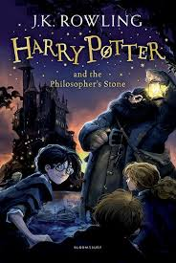 | 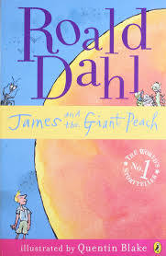
Charlie and the Chocolate Factory  by Roald Dahl | Grandpa’s Great Escape  by David Walliams | Ratburger  by David Walliams
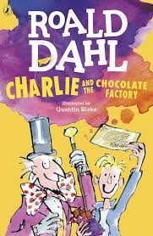 | 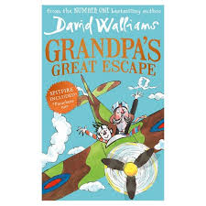 | 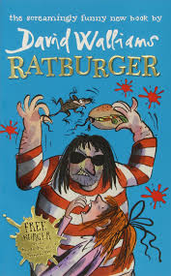
Wonder  by RJ Palacio | Charlotte’s Web  by EB White | Tracy Beaker  by Jacqueline Wilson
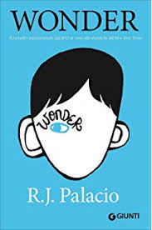 | 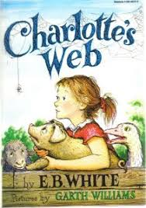 | 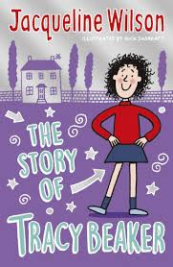
Goosebumps Books  by RL Stine | War Horse  by Michael Morpurgo | The Famous Five  by Enid Blyton
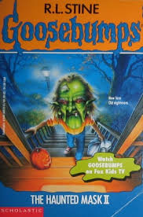 | 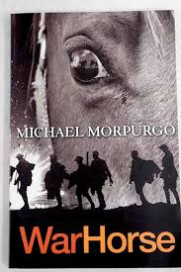 | 