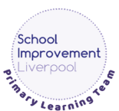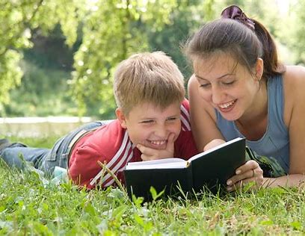**Why is reading so important?**



Reading at home **Year 4**

There is a vast amount of research that shows us how important reading with our children is. It helps to improve your child’s concentration and memory, develop their imagination, empathy, vocabulary and listening skills and takes them (and us!) to places we might never otherwise visit. It’s also excellent for wellbeing.

**The Importance of Reading Aloud to your Child**

As your child’s confidence grows in reading independently, it is still extremely beneficial for you to read aloud to them. In fact, research shows that reading aloud to your child will improve their reading and listening skills and academic performance and success.

**How else does reading aloud to your child help?**

**Positive modelling:** Your child will hear how the book should be read - with lots of expression and at just the right speed.

**It improves comprehension:** Your child will be able to focus on what’s happening in the story or on the information in the text, rather than having to work hard to read it aloud themselves.

**It sparks curiosity and a thirst for learning:** Reading aloud to your child allows them to access a wider range of texts beyond what they can read by themselves. You could choose to read fiction, factual books and news articles, for example. It encourages life-long learning.

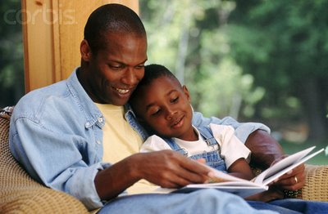**It is wonderful for bonding:** It’s a lovely opportunity for you to spend some dedicated time with your child, showing them how important they are and how important reading is.

**Getting the Most Out of Reading with your Child**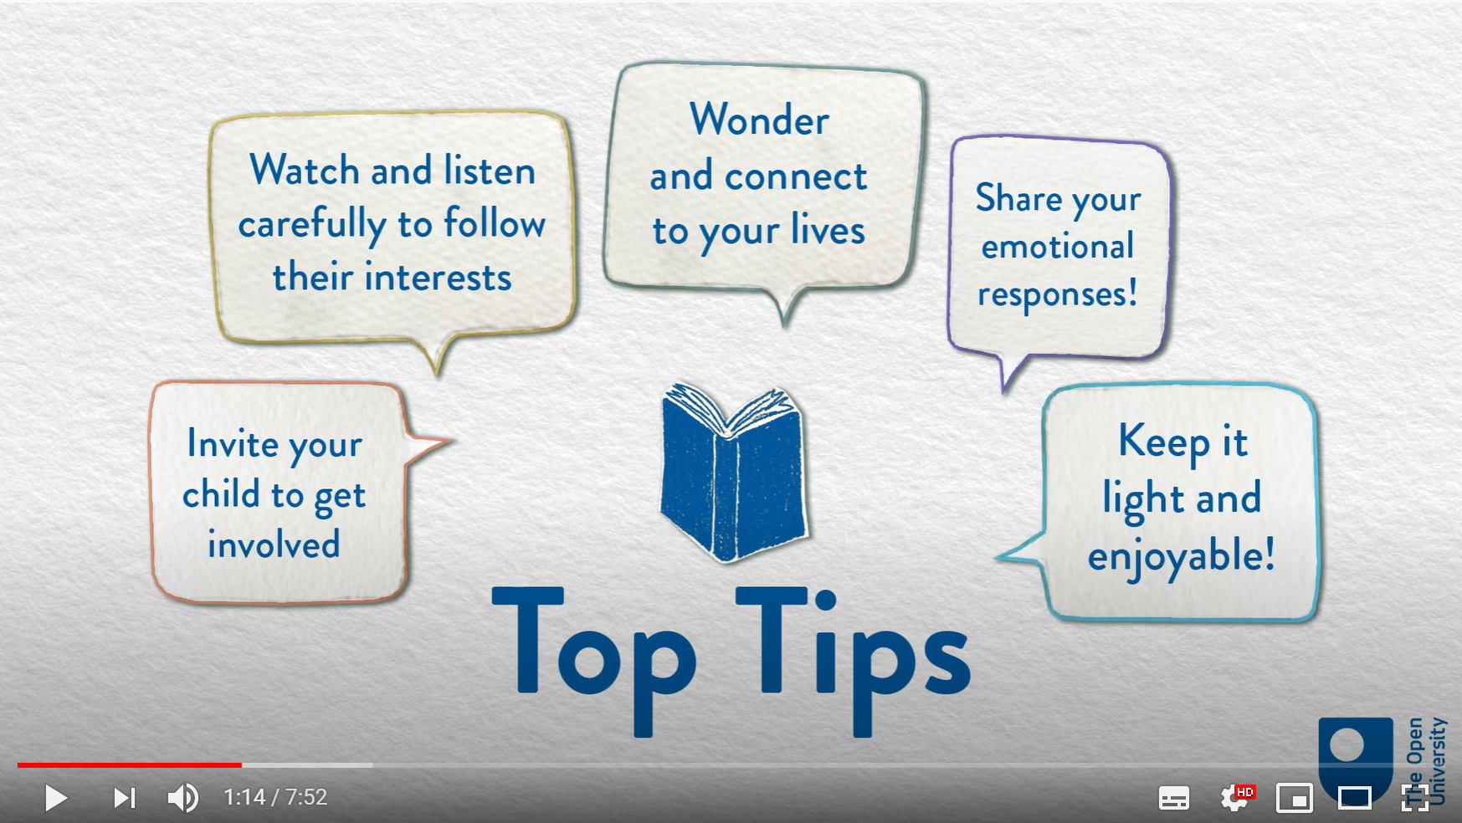

Watch this short video from The Open University to help you get the most out of reading with your child

Book Chat: Book Chat: Reading to your Child *The* *House that Once Was*:

<https://youtu.be/zNqG-RlwrIM>

**Listening to Your Child Read Aloud**

* Try to **listen to your child read** aloud daily (5 - 10 minutes is long enough) or **chat with them about what they are reading**.
* Choose a quiet, undistracted time and get comfortable.
* Support your child by encouraging them with any books being sent home by school. Keep in close contact with school if you have any concerns or want to share successes.
* When your child tries to 'sound out' words, encourage the use of phonics letter sounds rather than 'alphabet names'. So for ‘along’ you’d say a-l-o-n-g, not A-L-O-N-G.

**Join the FREE online library**

<https://www.readliverpool.co.uk/>

You can borrow 8 virtual books at a time for free!

* Be positive and give lots of praise!

©School Improvement Liverpool 2020

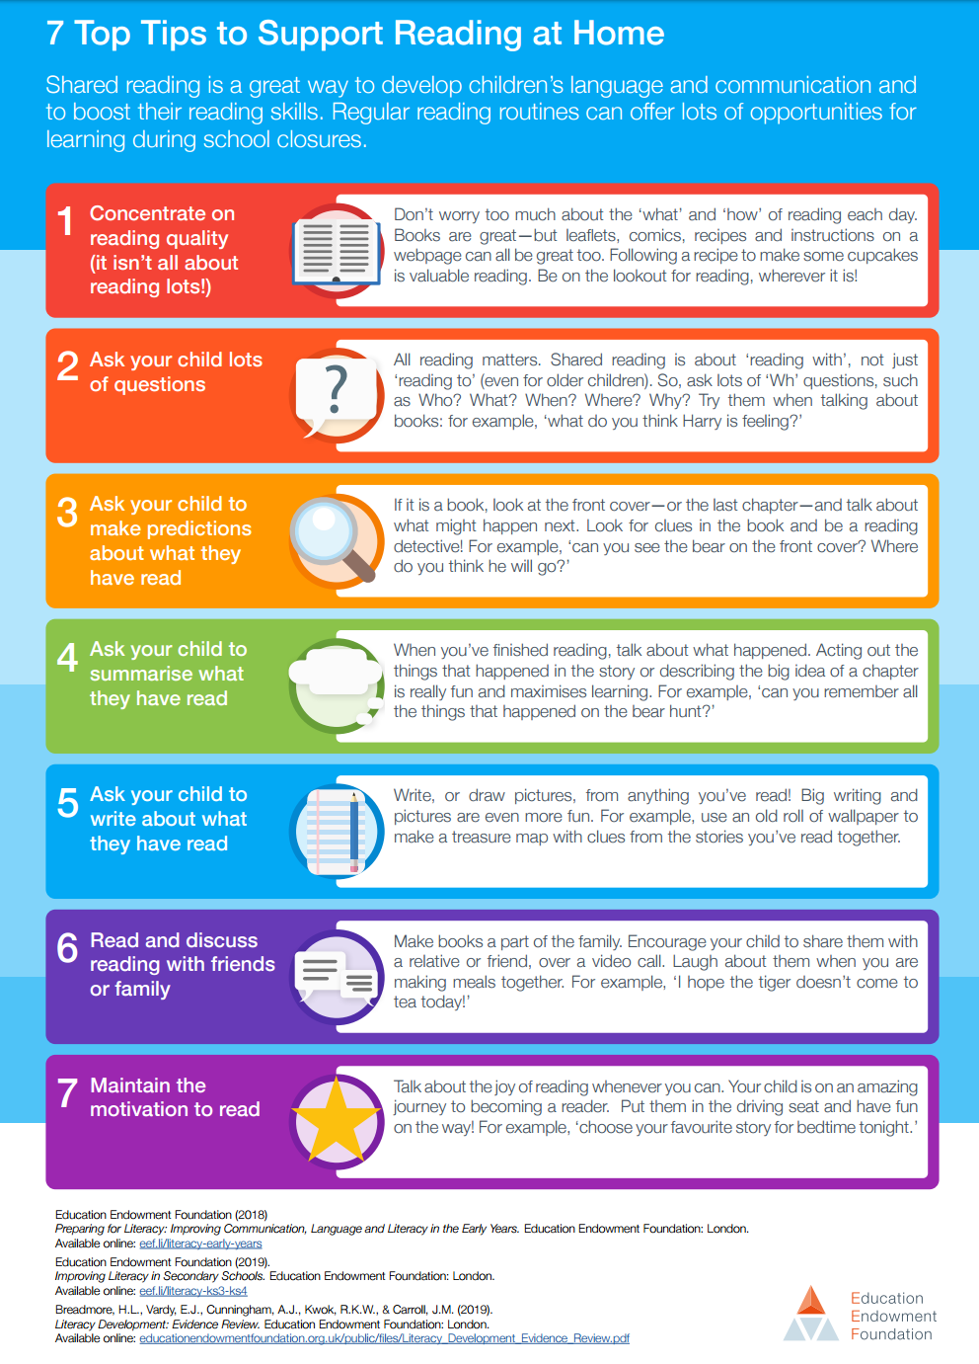



Questions to ask while reading with your child

It’s important to ask questions when you are reading to your child and when your

child is reading to you. You can ask questions before, during and after reading.

Questions can help you to see whether your child has understood what you’ve read

together. You can ask your child about:

**Words**

Find a word that means the same as…

Find a word which best describes the mood /character at this point in the story.

What does this word mean?

**Finding information**

What are the characters called?

Who is telling the story?

What word is used to describe the …?

**Summing it up**

What’s happened so far?

What do you think is the most important

point in in this paragraph/page?

What is the main message in this story/poem/text? Why?

**Using clues**

How is the character feeling at this point in the story? How do you know?

Why do you think the character did that?

Can you explain why…?

How can you tell that…?

What word is used to describe the …?

**What the author means**

What do you think the author meant by ____?

How does the author create this mood/atmosphere?

Why do you think the author used that word/phrase?

**Predictions**

What do you think might happen next?

If there was a sequel, what do you think might happen? Why?

What do you think would happen if…?

**Making comparisons**

How does the character’s mood/attitude change from the beginning to the end of the story?

How is this character/plot similar/different to…?

Have you ever read another book similar to this? How is it similar?

**The Whole Text**

Why do you think the writer has written/organised the test like this?

Who do you think this was written for? Why?

©School Improvement Liverpool 2020