**Talk, Talk, Talk!**



Writing at Home **Year 4**

**Audience and Purpose**

Audience and purpose

**Talking** with your child is one of the most powerful activities you can do. Use a wide range of **vocabulary** and try to use new words they have discovered when reading. Enter into discussions or debates with your child about issues they care about and talk through ideas they have for their writing. All of this talk will help them to develop vocabulary and refine their ideas for writing.

Encourage your child to think about **who** they are writing for and **why** they are writing. This will help them to make their writing more effective.

Who are you writing to?

Encourage your child to think about who they are writing for and why they are writing. This will help them to make their writing more effective.

**Be storytellers!**

Photographs, objects and images are a great way to stimulate memory and imagination. Explore your home, looking for photographs or objects that trigger memories. A pair of special shoes, photos of a family day out or a precious gift can be a great starting point for telling a story. Tell your own stories/memories to your child and let them tell theirs to you.

How do you want to make your reader feel?

What are you writing for?

**Handwriting**

In Year 4, your child will continue to develop fluent handwriting skills, making their writing more consistent and easier to read. This includes:

* joining letters whenever appropriate
* making sure that letters look consistent throughout writing
* ****keeping the spacing between lines of writing parallel and consistent.

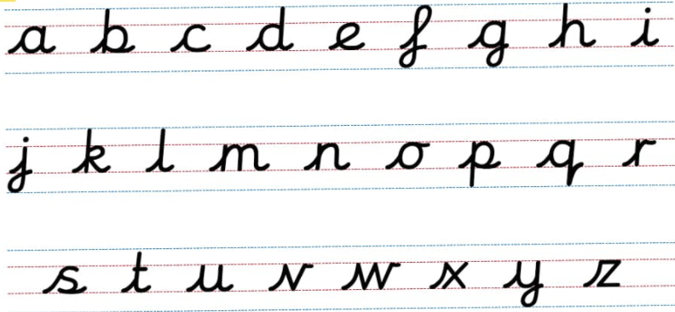

 Sit at a desk

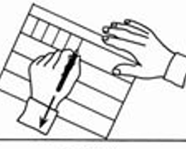 Put both feet on the floor

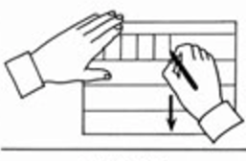 Left hand paper position

Right hand paper position

**Check and progress!**

**How can you motivate your child to write?**

* Make sure your child knows their work doesn’t have to be perfect first time. They can go back and make improvements later.
* Share your own writing. Let your child see you writing. Whether it be a postcard to a family member, a journal entry or text messages, let your child know you’re using your writing skills for real purpose.
* Encourage your child to write about their interests and hobbies.
* Let them use a computer if they’d prefer to type and they engage more in their writing.

A great way to help your child to improve their writing is to encourage them to read aloud what they have written. Can they spot any missed punctuation? Can they spot any spelling errors? Can they add in extra detail?

©School Improvement Liverpool 2020

Writing checklist:

Can your child use speech marks “ ” to show when someone is speaking?

(Direct speech)

Can your child read aloud, with expression, what they have read?

**Can your child spell these tricky words?**

accident, accidentally, actual, actually, address, answer, appear, arrive, believe, bicycle, breath, breathe, build, busy, business, calendar, caught, centre, century, certain, circle, complete, consider, continue, decide, describe, different, difficult, disappear, early, earth, eight, eighth, enough, exercise, experience, experiment, extreme, famous, favourite, February, forward, forwards, fruit, grammar, group, guard, guide, heard, heart, height, history, imagine, increase, important, interest, island, knowledge, learn, length, library, material, medicine, mention, minute, natural, naughty, notice, occasion, occasionally, often, opposite, ordinary, particular, peculiar, perhaps, popular, position, possess, possession, possible, potatoes, pressure, probably, promise, purpose, quarter, question, recent, regular, reign, remember, sentence, separate, special, straight, strange, strength, suppose, surprise, therefore, though, although, thought, through, various, weight, woman, women

**Can your child tell you what these words are/mean?**

adverb a word that describes a verb or adjective. e.g. *quietly, above, yesterday, very, sometimes*

preposition linking words that tell us where or when something is happening. *e.g. under, on, while, down*

conjunction a word that links sentences together. e.g. *and, but, or, so, because, when, after, while*

word family words that are related to each other. e.g. *teach → teacher, medic → medical → medicine*

prefix added at the beginning of a word to make a new word. e.g. *disappear, overtake, enjoy*

clause a special type of phrase https://www.youtube.com/watch?v=pWS3Cbf5h9U

subordinate clause a clause that relies on another part of the sentence. It cannot be a sentence by itself.

direct speech a sentence which contains the exact words spoken, surrounded by speech marks“ ”

consonant most of the letters on the alphabet represent consonants except a, e, i, o, u

consonant letter vowel the letter ‘y’ sometimes acts like a vowel. .e.g. rhythm

vowel letter a, e, i, o, u

inverted commas (or ‘speech marks’) “ ” The punctation marks used for direct speech.

©School Improvement Liverpool 2020

Other ways you can make a big difference

Look for opportunities to give your child some real-life reasons to write. You could try out some of these ideas:

* Write a lockdown letter to cheer up a family member, a friend or a neighbour. Post it together. You might even start a pen pal tradition! You could include artwork too if this is something your child enjoys doing.
* Is there an issue your child cares passionately about? Encourage them to write to a local MP or business to see whether they can create change. This kind of writing can make big differences in the community.
* Work together to send a tweet to your child’s favourite author. Many authors are now on Twitter and love to engage with their readers. What would your child like to ask their favourite author?
* Your child might like to write the book version of a film or TV programme for younger children to read. If your child has watched something they’ve really enjoyed, they could try and tell the same story in writing. Watching the story on screen can give them a great starting point to get going with.
* If you’ve had a recent visit to a park, library or museum, etc that you have enjoyed with your child, help them to add a review on <https://www.tripadvisor.co.uk/>. Having a real audience who will read their review will often motivate children to write.
* Write book reviews for books your child has read. <https://www.lovereading4kids.co.uk/> is a great website for this.

©School Improvement Liverpool 2020

* Could your child start a blog around their own interest?

Important Information

Key authors for the children this year are JK Rowling and David Walliams.