
Emmaus Primary School

Special Educational Needs and Disabilities (SEND)
Information for Parents & Carers

What is SEND?


Every child is an individual who develop and learn at different rates. Different teaching styles are used in the classroom to support the varying needs of every child. All children benefit from these different approaches but sometimes may require additional support to help them to make further progress.

What should I do if I think my child is experiencing some difficulties?

If you are concerned that your child is experiencing some difficulties in school you should speak to the class teacher or Special Educational Needs Co-ordinator (SENDCO), Liz Kelly.
All pupils make progress at different rates. If your child is experiencing difficulties, teachers will monitor and review progress and will adopt flexible strategies in order to meet your child’s needs within the class.


What is SEN Support?

If your child requires support or provision that is additional to or from everyday classroom practices, the SENDCO will work with their teacher and support staff to provide an individualised programme of work called a ‘Pupil Profile’. This will be delivered by the class teacher, in collaboration with the SENDCO.

The SENDCO plans interventions that are additional to or different from the usual daily curriculum and the class teacher is responsible for working with your child on a daily basis to support this.
This will continue unless it is felt that outside agencies could provide further advice and support.

If your child continues to experience difficulties over time, the SENDCO, in consultation with you, will seek advice from outside agencies and specialists. Additional or different strategies may be put in place and support obtained from an outreach specialist service.

The school ensures that:

Your child’s progress is reviewed regularly to set outcomes, plan strategies, develop learning programmes and assess attainment

Teaching strategies are responsive to your child’s needs and abilities

Groupings within class help children to feel secure and confident and support them in making progress

Additional support is used within the classroom, in small groups and on an individualised basis

Any advice and strategies from specialist agencies is fully utilised and accessed within the school.
Pupils on the SEND register are generally categorised into the following four broad areas of need:

• Cognition and Learning
• Physical and Sensory
• Social, Emotional and Mental Health
• Communication and Interaction

The SEND register at Emmaus remains fluid. Pupils are added/taken off the register as the need arises following the Graduated Response of Assess, Plan, Do, Review.

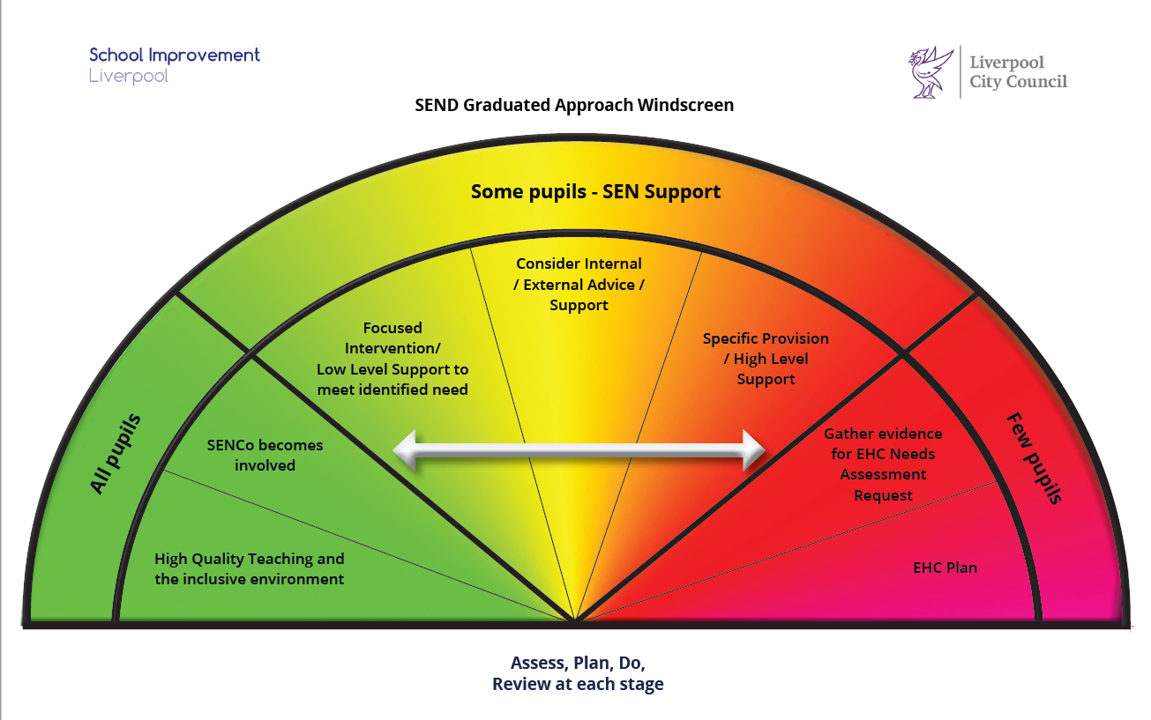

SEND Pupil Profiles
When your child is placed on the SEND register, an individualised programme is set up to support their needs. This is devised in consultation with the SENDCO, class teacher, parent/carer and child. The Pupil Profile is person centred and records what strategies are effective to support your child in achieving their outcomes.
The aim of the Pupil Profile is to promote effective learning and contains information such as:

- What we like and admire about your child.
- What is important to your child.
- How we can support your child.
- Outcomes/aspirations for your child to work towards.
Pupil Profiles are reviewed each term and parents/carers are invited into school to discuss outcomes and strategies for support at home and in school

Current Outreach Support accessed by some of the children at Emmaus:

SALT: Speech, language and social communication support
EMTAS: EAL support
SENNIS: Support/advice for Cognition and Learning, Irlen Syndrome, ASD
OT: Support and advice accessed for pupils with physical or profound difficulties. Support, advice and relevant resources to manage sensory processing difficulties.
Physiotherapy: Strategies and support accessed for pupils with physical needs and multiple difficulties to allow appropriate access to the environment and curriculum
Croxteth Children’s centre: Liaison between SENDCO and centre staff to facilitate parenting courses and support for families and young children
CAAT Team: Advice, support, training and resources to provide ICT equipment for pupils with communication and physical difficulties
Parent Services/SENDIAS: An advisory parent/carer support service. Parents/carers can contact the team to offer advice with tribunals, reviews, form filling and secondary school placements
D.S. Association: Accessed by both school and home to ensure an appropriate and relevant curriculum for the children in our school
ADHD Foundation:Training for staff and referral for individual pupils with ADHD needs
Autism Initiatives: Training, observation, advice and assessment for teachers, TAs, parents and pupils relating to ASC
Alder Hey: SENDCO refers pupils and arranges appointments for parents/carers with the Community Paediatrician team and organises team meetings in school to ensure that strategies and advice are adhered to by all parties
School Health: SENDCO regularly contacts the school health team to advice and assess children who require physical, medical or health interventions. School Nurse offers ‘health drop-ins’ for parents who have any concerns
YPAS Seedlings Project: SENDCO refers pupils to this counselling project which takes place in school on a weekly basis and provides therapeutic counselling support to children and their families.

What if my child needs further support which cannot be provided through the school?

The majority of children will receive the help they need at school. For a very few pupils additional support will need to be sought in order to ensure your child achieves the best possible outcomes and progress.


If your child needs further support the SENDCO will discuss this with you and with any agencies already involved in supporting your child. At this stage a request may be made to the Local Authority to carry out a statutory assessment (EHC assessment).

The LA will consider evidence from all involved with your child and will decide whether to carry out a statutory assessment. If the decision is made to agree to a statutory assessment, detailed information is collated about your child and an Education and Health Care Plan will be written. This will set out your child’s needs, detail outcomes and the provision and resorcing required in order that progress can continue.

What help will be available for my child?

This depends on your child’s needs or difficulties, and how well he / she is progressing. The school will work with you to ascertain the best way to help your child. This may include:

• Changing the way your child is taught: e.g. giving instructions in a different way, different reading books etc.
• Provision tailored to your child’s needs
• Teaching in small groups or on a 1:1 basis for some of the time
• Support from a Teaching Assistant or Learning Support Teacher
• More detailed assessments or more frequent reviews of progress to support learning
• Specialist equipment.

Your child’s progress will be regularly reviewed to ensure that he / she is receiving the appropriate, relevant support.
The school follows guidelines set out in the Special Educational Needs Code of Practice 2014 to ensure that needs are identified and met.


How can I help my child?
Parents/carers play a vital role in their child’s education. To help the school work effectively with your child it is important that you:
- encourage and praise your child for what they achieve.
- support your child's learning by helping with homework.
- read with your child every day.
- always contact the school if you have any concerns or questions about your child's education.
- ask for an explanation if you are unsure about what people are saying.
- attend parents’ evenings, concerts, class assemblies, etc. whenever possible - let your child know you are interested in what they are doing at school
- share all the relevant information with your child’s school and other professionals involved as you know your child better than anyone.
You could also
- use the school’s website (emmausprimaryschool.org.uk parent information section) to seek information and relevant support services and agencies.
- offer to help in the school, if you can.
- encourage your child to take part in activities/clubs outside of the school curriculum.
- seek advice, support and training from relevant teams (see list of website addresses and organisations on the Emmaus website).

If you have any worries or concerns at all about your child then please do not hesitate to talk to:

Liz Kelly, Special Educational Needs Co-ordinator (SENDCO)
0151 233 1414 e.kelly@emmaus.liverpool.sch.uk

