



**Year 3**

Supporting your child with English at home



Home-learning can be challenging for both you and your child as everyone is adapting to this unusual situation. The following advice aims to offer to helpful, practical tips with supporting your child’s reading and writing while at home:

Preparing to learn: Some top tips

*Based on Maslow's hierarchy of needs*

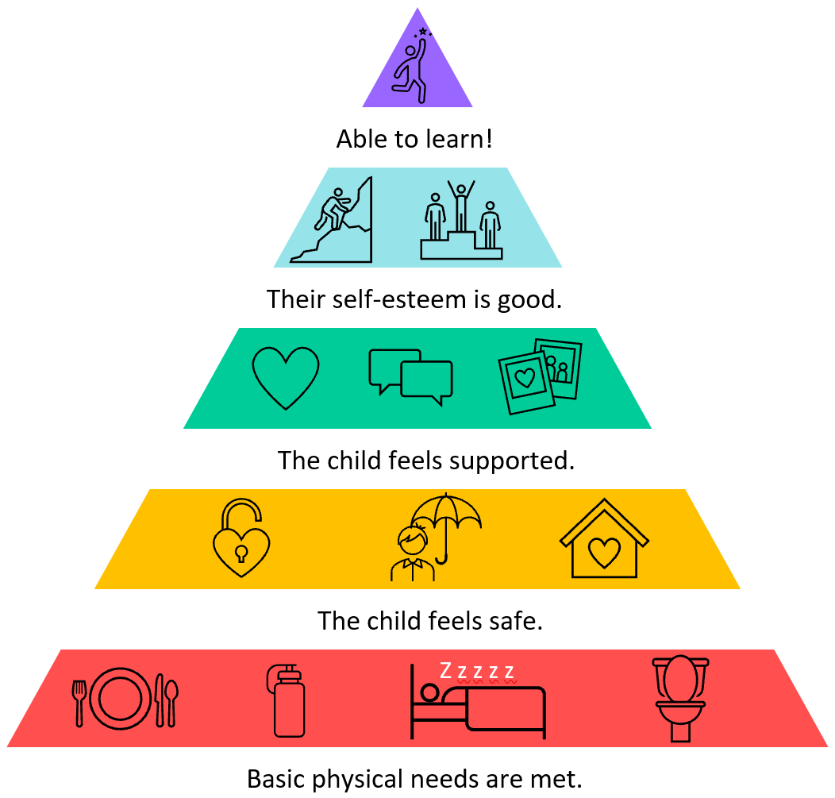

* Ensure your child’s **basic needs** have been met: Are they thirsty, for

example?

* Make sure your child has a **clear space to work**. Think about the

task they have to do – where might they be the most productive/ comfortable?

* Create a new **routine** that works around your family. If possible, involve your child in establishing routines that will enable them to manage the tasks set for them. Your routines should include **regular breaks**, ideally with fresh air.
* Tackle tasks in **short bursts** if your child is finding it difficult to concentrate.
* Where possible, allow your child **choices**. For example, if your child has been given two tasks for the day, give them the choice of which one to do first.
* **Model positive behaviours** to your child.

Talk about the strategies you use to help you get through your daily tasks. If something isn’t working, talk it though.

* Look for the positives: Things won’t always go according to plan. Try to focus on what is going well rather than what has gone wrong. Try to support your child with lots of **praise and encouragement**.
* Consider family **wellbeing**: <https://www.nhs.uk/oneyou/every-mind-matters/>
* Tips for anxiety: <https://www.childrens.com/health-wellness/8-tips-for-managing-childrens-anxiety-about-covid-19>

©School Improvement Liverpool 2020

Giving just the right amount of support

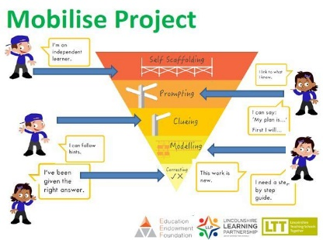It’s important that you try to encourage independence when working with your child.

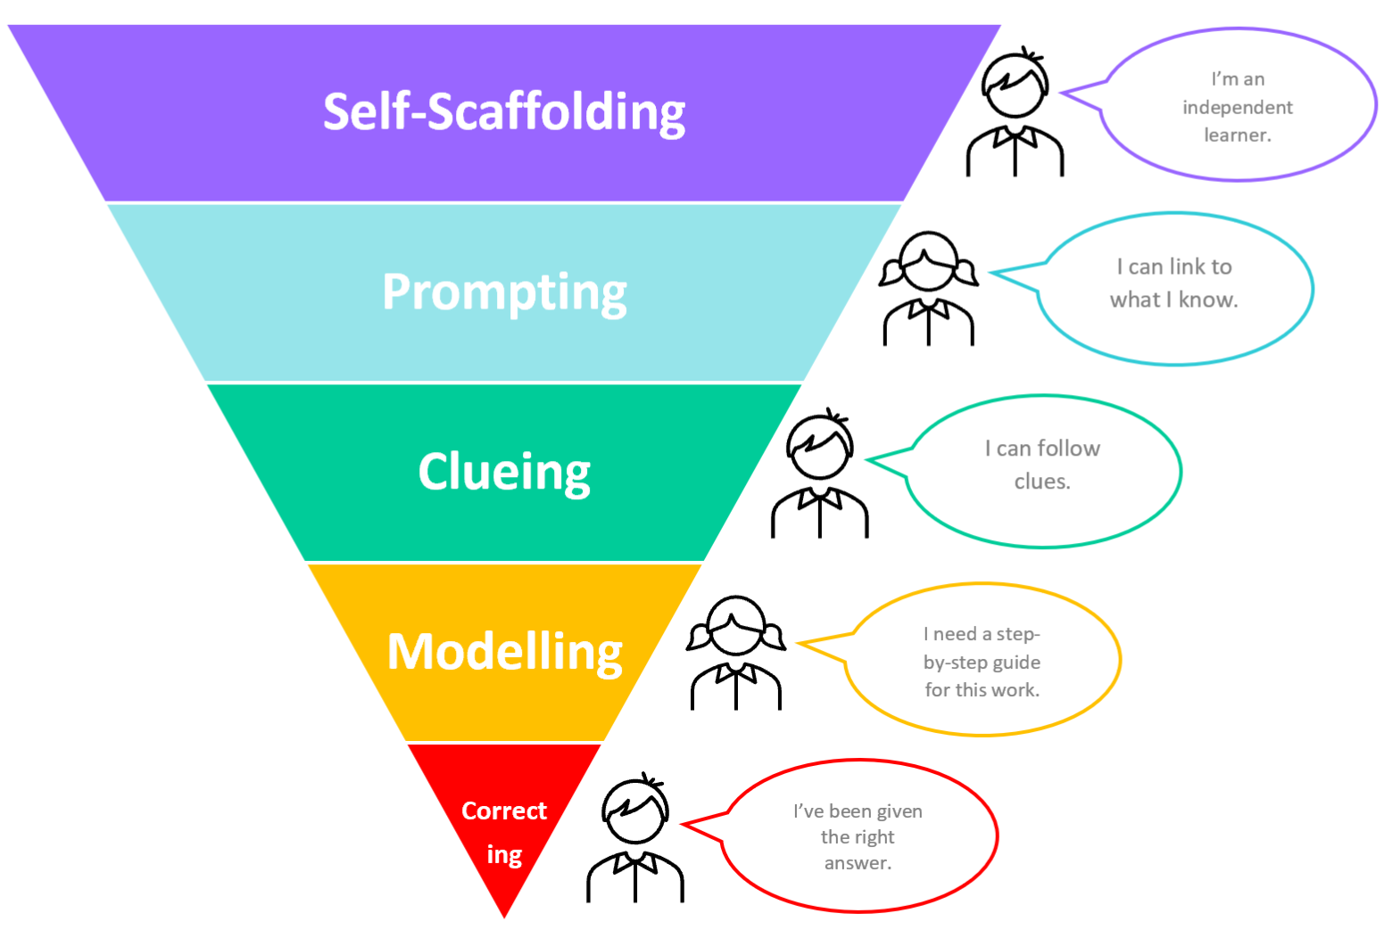You can do this by:

**Self-scaffolding -** This is where your child is working largely by themselves.

**Prompting -** You can give a prompt when your child needs just a little help to carry on working by themselves. For example: ‘What do you need to do first?’; ‘What’s your plan?’; ‘You can do this!’

**Clueing -**  Your child might need a hint about their work to keep them on track. Always start with a small clue, then give a bigger clue if your child needs one. For example, ‘What does a sentence always begin with?’or ‘Let’s go back and re-read this sentence again… I think you might have missed something out.’

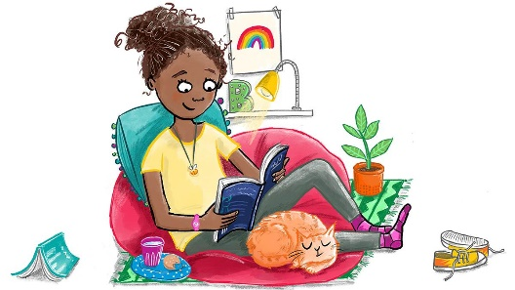**Modelling -** Sometimes it is really useful for you to model what to do while your child watches and listens. Your child should try the same step for themselves immediately afterwards.

Illustration: Hannah Shaw

**Correcting –** Only very occasionally, you may need to give your child answers.

Try to encourage your child to work independently as much as they can.

*Adapted from: Bosanquet, P., Radford, J. and Webster, R. (2016)*

Take care of yourself too!

Looking after yourself will have an impact on how you support your child at home. Fresh air each day if possible, a few moments of quiet, enough water to drink and some exercise are all good places to start. Be kind to yourself!

[(Adapted from the Book Trust Website)](https://www.booktrust.org.uk/news-and-features/features/2020/june/how-to-help-your-children-return-to-school-5-top-tips/)

<https://www.booktrust.org.uk/news-and-features/features/2020/june/how-to-help-your-children-return-to-school-5-top-tips/>

Completing tasks

It’s also important not to be too concerned about your child completing every single task. If your child has tried hard but has not been able to complete a task, let your child’s teacher know. Your child’s teacher recognises how challenging working at home can be for you and your child.

Do what you can: Everybody’s circumstances are different and we do understand that.

**Why is reading so important?**



©School Improvement Liverpool 2020