``



**Year 3**

Supporting your child with English at home



Home-learning can be challenging for both you and your child as everyone is adapting to this unusual situation. The following advice aims to offer to helpful, practical tips with supporting your child’s reading and writing while at home:

Preparing to learn: Some top tips

*Based on Maslow's hierarchy of needs*

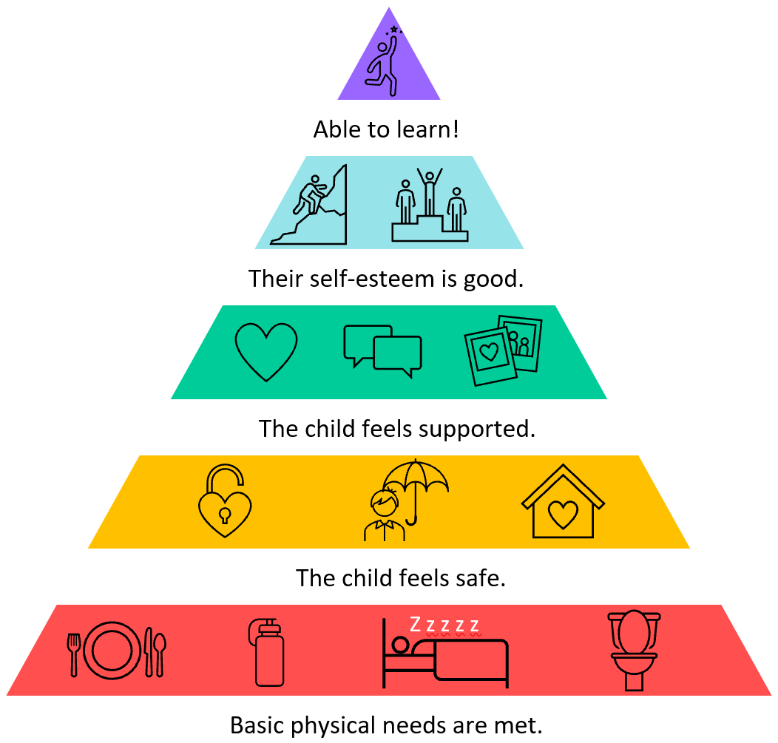

* Ensure your child’s **basic needs** have been met: Are they thirsty, for

example?

* Make sure your child has a **clear space to work**. Think about the

task they have to do – where might they be the most productive/ comfortable?

* Create a new **routine** that works around your family. If possible, involve your child in establishing routines that will enable them to manage the tasks set for them. Your routines should include **regular breaks**, ideally with fresh air.
* Tackle tasks in **short bursts** if your child is finding it difficult to concentrate.
* Where possible, allow your child **choices**. For example, if your child has been given two tasks for the day, give them the choice of which one to do first.
* **Model positive behaviours** to your child.

Talk about the strategies you use to help you get through your daily tasks. If something isn’t working, talk it though.

* Look for the positives: Things won’t always go according to plan. Try to focus on what is going well rather than what has gone wrong. Try to support your child with lots of **praise and encouragement**.
* Consider family **wellbeing**: <https://www.nhs.uk/oneyou/every-mind-matters/>
* Tips for anxiety: <https://www.childrens.com/health-wellness/8-tips-for-managing-childrens-anxiety-about-covid-19>

©School Improvement Liverpool 2020

Giving just the right amount of support

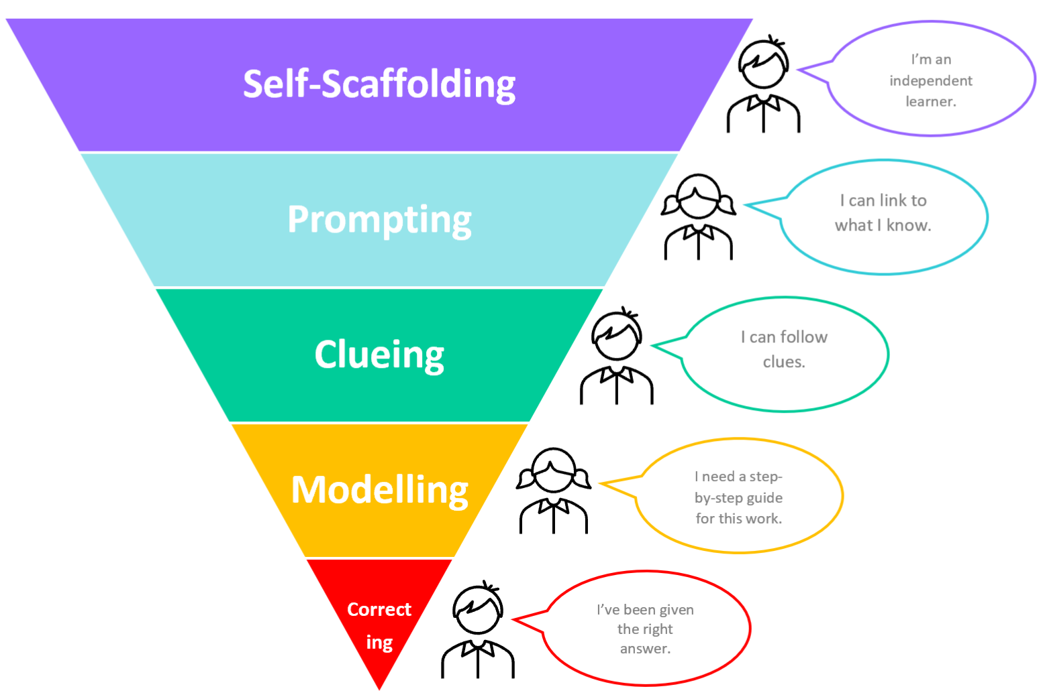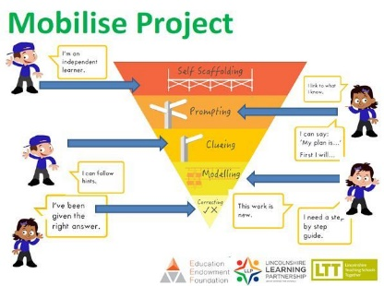It’s important that you try to encourage independence when working with your child.

You can do this by:

**Self-scaffolding -** This is where your child is working largely by themselves.

**Prompting -** You can give a prompt when your child needs just a little help to carry on working by themselves. For example: ‘What do you need to do first?’; ‘What’s your plan?’; ‘You can do this!’

**Clueing -**  Your child might need a hint about their work to keep them on track. Always start with a small clue, then give a bigger clue if your child needs one. For example, ‘What does a sentence always begin with?’or ‘Let’s go back and re-read this sentence again… I think you might have missed something out.’

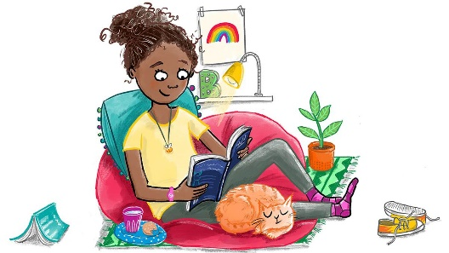**Modelling -** Sometimes it is really useful for you to model what to do while your child watches and listens. Your child should try the same step for themselves immediately afterwards.

Illustration: Hannah Shaw

**Correcting –** Only very occasionally, you may need to give your child answers.

Try to encourage your child to work independently as much as they can.

*Adapted from: Bosanquet, P., Radford, J. and Webster, R. (2016)*

Take care of yourself too!

Looking after yourself will have an impact on how you support your child at home. Fresh air each day if possible, a few moments of quiet, enough water to drink and some exercise are all good places to start. Be kind to yourself!

[(Adapted from the Book Trust Website)](https://www.booktrust.org.uk/news-and-features/features/2020/june/how-to-help-your-children-return-to-school-5-top-tips/)

<https://www.booktrust.org.uk/news-and-features/features/2020/june/how-to-help-your-children-return-to-school-5-top-tips/>

Completing tasks

It’s also important to not be too concerned about your child completing every single task. If your child has tried hard but has not been able to complete a task, let your child’s teacher know. Your child’s teacher recognises how challenging working at home can be for you and your child.

REMEMBER: Do what you can.

Everybody’s circumstances are different and we do understand that. If you need further support from school, please contact:

****************************************

©School Improvement Liverpool 2020

******Why is reading so important?**

School Logo

Reading at home Year 3

There is a vast amount of research that shows us how important reading with our children is. It helps to improve your child’s concentration and memory, helps to develop their imagination, empathy, vocabulary and listening skills and takes them (and us!) to places we might never otherwise visit. It’s also excellent for wellbeing.

**The Importance of Reading Aloud to your Child**

**Reading aloud to your child** is very beneficial for them, even when they can read by themselves. In fact, research shows that reading aloud to your child after the age of 5 will improve their reading and listening skills and academic performance.

****How else does reading aloud to your child help?

**Positive modelling:** Your child will hear how the book should be read -with lots of expression and at just the right speed.

**It improves comprehension:** Your child will be able to focus on what’s happening in the story or on the information in the text, rather than having to work hard to read it aloud themselves.

**It sparks curiosity and a thirst for learning:** You can use books to guide your child to find out more about the things you are reading and talking about.

**It is wonderful for bonding:** It’s a lovely opportunity for you to spend some dedicated time with your child, showing them how important they are and how important reading is.

**Getting the Most Out of Reading with your Child**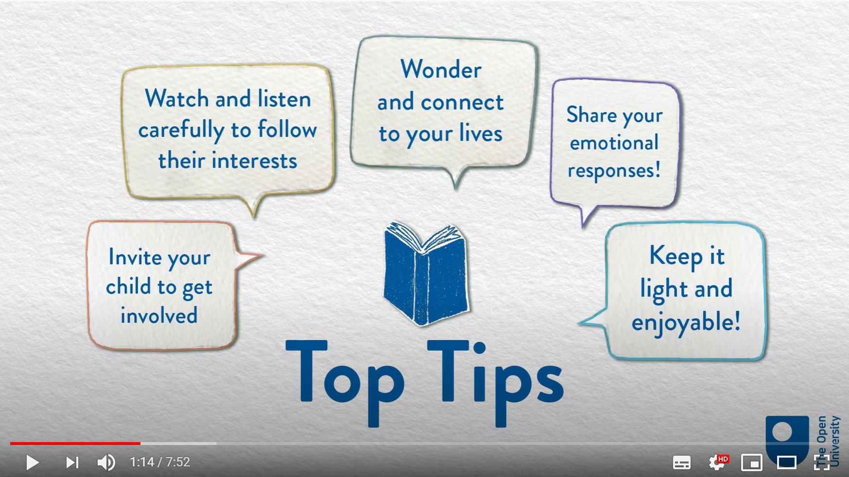

Watch this short video from The Open University to help you get the most out of reading with your child

Book Chat: Book Chat: Reading to your Child *The* *House that Once Was*:

<https://youtu.be/zNqG-RlwrIM>

**Listening to Your Child Read Aloud**

* Try to **listen to your child read** aloud daily. Little and often is best. 5 - 10 minutes is usually long enough.

**Join the FREE online library**



<https://www.readliverpool.co.uk/>

You can borrow 8 virtual books at a time for free!

* Choose a quiet, undistracted time and snuggle up.
* Use the book that school has sent home specifically for this reason.
* Re-read the same text over the course of a week. This will help to build up your child’s fluency.
* When your child tries to 'sound out' words, encourage the use of phonics letter sounds rather than 'alphabet names'. So for ‘cat’ you’d say c-a-t; not C-A-T (see-ay-tea).
* Be positive. Give lots and lots of praise.

©School Improvement Liverpool 2020

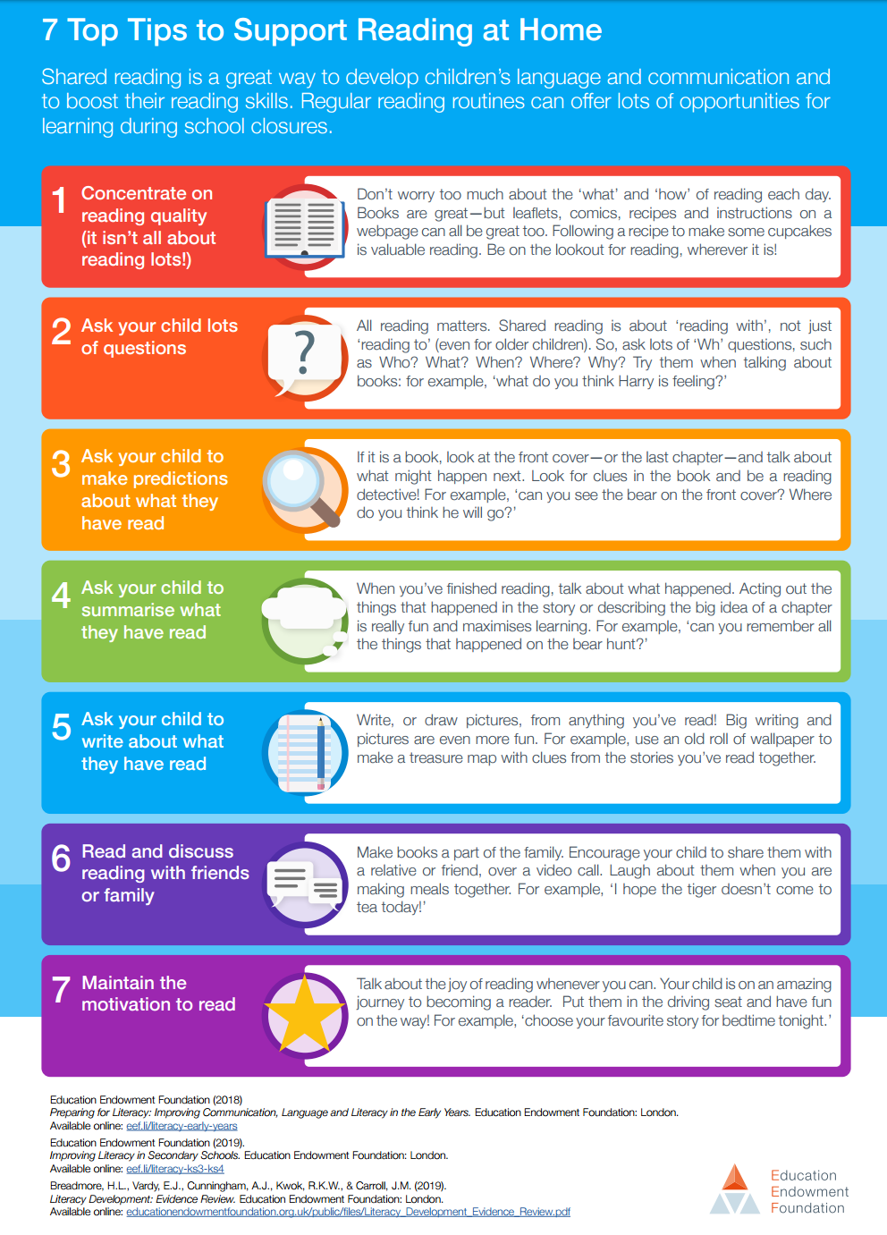



Questions to ask while reading with your child

It’s important to ask questions when you are reading to your child and when your

child is reading to you. You can ask questions before, during and after reading.

Questions can help you see whether your child has understood what you’ve read

together. You can ask your child about:

**Words**

Find a word that means the same as…

Find a word which best describes the mood /character at this point in the story.

What does this word mean?

**Finding information**

What are the characters called?

Who is telling the story?

What word is used to describe the …?

**Using clues**

How is the character feeling at this point in the story? How do you know?

Why do you think the character did that?

Can you explain why…?

How can you tell that…?

What word is used to describe the …?

**Summing it up**

What’s happened so far?

What do you think is the most important

point in in this paragraph/page?

What is the main message in this story/poem/text? Why?

**What the author means**

What do you think the author meant by ____?

How does the author create this mood/atmosphere?

Why do you think the author used that word/phrase?

**Predictions**

What do you think might happen next?

If there was a sequel, what do you think might happen? Why?

What do you think would happen if…?

**The Whole Text**

Why do you think the writer has written/organised the test like this?

Who do you think this was written for? Why?

**Making comparisons**

How does the character’s mood/attitude change from the beginning to the end of the story?

How is this character/plot similar/different to…?

Have you ever read another book similar to this? How is it similar?

©School Improvement Liverpool 2020



School Logo

Writing at Home Year 3

**Be chatterboxes!**

Talking for Writing

Children love to talk and it’s so good for them too! In fact, talking **with** your child is one of the most powerful activities you can do. Use a wide range of vocabulary and try to use the new words you have discovered when reading together. Talk about everything: experiences you can remember, what you see in the world around you and explanations of everyday activities, e.g. washing the dishes or cooking dinner. All of this talk helps children to explore and understand language and can have a really positive impact on their writing.

What are you going to write about?

Encourage your child to talk about, or say out loud, what they are going to write. This helps them to prepare for writing.

Can you say the sentence aloud before you write it down?

**Be storytellers!**

Photographs, objects and images are a great way to stimulate memory and imagination. Explore your home, looking for photographs or objects that trigger memories. A pair of special shoes, photos of a family day out or a precious gift can be a great way to tell a story. Tell your own stories/memories to your child and let them tell theirs to you.

Can you read aloud what you have written?

**Handwriting**

In Year 3, your child will start developing fluent handwriting skills, making their writing more consistent and easier to read. This includes:

* joining letters whenever appropriate
* making sure that letters look consistent throughout writing
* ****keeping the spacing between lines of writing parallel and consistent.

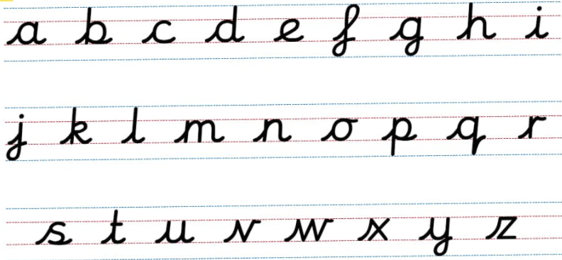

 Sit at a desk

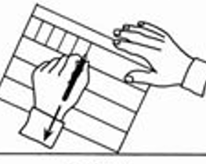 Put both feet on the floor

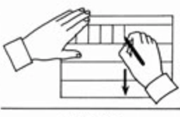 Left hand paper position

Right hand paper position

**Check and progress**

A great way to help your child to improve

**How can you motivate your child to write?**

- Make sure your child knows their work doesn’t have to be perfect first time. They can go back and make improvements later.

- Share your own writing. Let your child see you writing. Whether it be a postcard to a family member, a journal entry or text messages, let your child know you’re using your writing skills for real purpose.

- Encourage your child to write about their interests and hobbies

their writing is to encourage them to read

aloud what they have written. Can they

spot any missed punctuation? Can they

spot any spelling errors?

©School Improvement Liverpool 2020

Writing checklist:

Is your child using tense correctly throughout their writing?

Can your child read aloud what they have written?

**Can your child spell these tricky words?**

door, floor, poor, because, find, kind, mind, behind, child, children, wild, climb, most, only, both, old, cold, gold, hold, told, every, everybody, even, great, break, steak, pretty, beautiful, after, fast, last, past, father, class, grass, pass, plant, path, bath, hour, move, prove, improve, sure, sugar, eye, could, should, would, who, whole, any, many, clothes, busy, people, water, again, half, money, Mr, Mrs, parents, Christmas

**Can your child tell you what these words are/mean?**

noun A word for a person , place or thing. There are proper nouns and common nouns. e.g. *door*

noun phrase A group of words based around a noun. e.g. *bright red door*

statement The most common type of sentence. They tell the reader a fact/idea. Usually end with a full stop.

question A sentence that asks something. Ends with a question mark. ?

exclamation A sentence that shows intense feeling or gets attention. Ends with exclamation mark!

command A sentence which tells someone to do something.

compound A compound word contains at least two root words. e.g. toothbrush, carpark

suffix An ‘ending’ used at the end of a word to turn it into another. e.g. call→called, teach→teacher

adjective A word that describes a noun. <https://www.bbc.co.uk/bitesize/topics/zrqqtfr/articles/zy2r6yc>

adverb A word that can modify a verb, an adjective or another adverb. <https://www.theschoolrun.com/what-is-an-adverb>

verb tense The tense of a verb (action word) tells us whether something happened in the past or present

apostrophe A punctuation mark with two different uses: e.g. can’t and Lucy’s. ‘

comma A punctuation mark that shows a pause or separates items in a list. ,

©School Improvement Liverpool 2020



Other ways you can make a big difference

Look for opportunities to give your child some real- life reasons to write. Try these ideas:

* Write a lockdown letter to cheer up a family member, a friend or a neighbour. Post it together. You might even start a pen pal tradition! You could include artwork too if this is something your child enjoys doing.
* Is there an issue your child cares passionately about? Encourage them to write to a local MP or business to see whether they can create change. This kind of writing can make big differences in the community.
* Work together to send a tweet to their favourite author. Many authors are now on twitter and love to engage with their readers. What would your child like to ask their favourite author?
* Your child might like to write the book of a film or TV programme for younger children to read. If children have watched something they’ve really enjoyed, they could try and tell the same story in writing. Watching the story on screen can give them a really great starting point to get going with.
* If you’ve had a recent visit to a park, library, museum, etc that you have enjoyed with your child, help them to add a review on <https://www.tripadvisor.co.uk/>. Having a real audience who will read their review will often motivate children to write.
* Write book reviews for books your child has read. <https://www.lovereading4kids.co.uk/> is a great website for this.

©School Improvement Liverpool 2020

* Could your child start a blog around their own interest?

Important Information

Important Information